1. In the last lectures, we learnt about **embedded or nested documents** and arrays and this gives you a lot of **flexibility to structure** your data in the way you need it to be structured.
2. We will go into deeper in data schema and modeling and relations module.
3. Let’s see how to access such structured data. Let’s start with hobbies here which is an array inside the document.
4. Let’s see how to query array.
5. 
6. 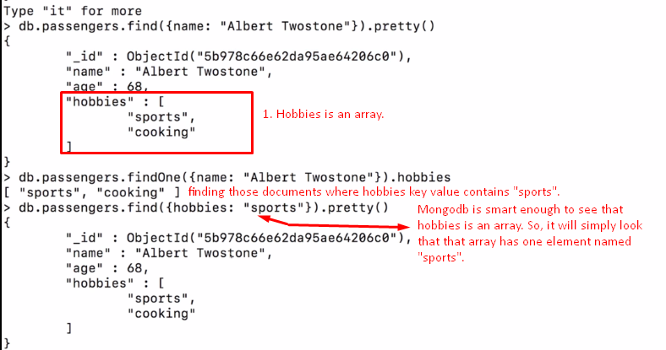
7. Let’s see how to query nested object.
8. 
9. 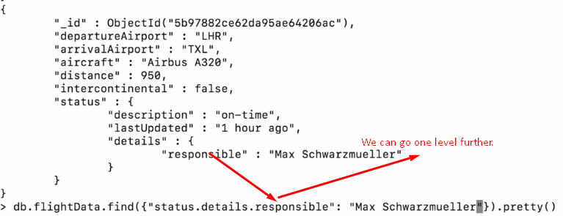
10. *So this **dot notation** is also something we will see a lot in this course as this is an important syntax that allows you to look into embedded documents in your filters.